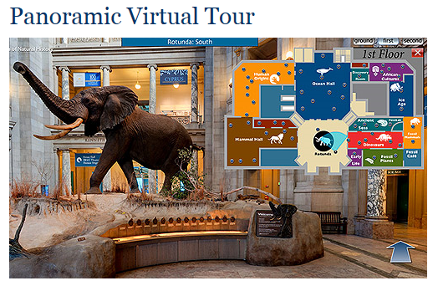
Take a Tour through the Past
This lesson focuses on the Mesozoic Era and Cenozoic Era’s. For this assessment you will Find an EXTINCT animal in the museum from either era and pretend you are interviewing them.
Smithsonian Museum of Natural History – Panoramic Virtual Tour
Click the opening image of the elephant to enter the virtual tour.. You can find the map in the upper right corner of your screen Go on a tour of the museum looking at all of the various animals that can be found there. Find 1 that interests you from the Mesozoic or Cenozoic Era. You will need to complete research on this animal to answer the questions for the interview that are provided for you.
Interview Question #1: What is your scientific name? Vulpes lagopus
Interview Question #2: What is your common name? arctic fox
Interview Question #3: What era were you found in? What period of that era were you found? Cenozoic, during Pliocene.
Interview Question #4: What do you look like? (discuss things like color, skin or feathers, how many legs, does it have a tail, etc.) I have four limbs, white skin color covered with fur. I have a tail.
Interview Question #5: Did you live on the land or in the water? How did you move? I lived on land and moved from one point to the other by pouncing and punching through the snow with my four limbs.
Interview Question #6: How did you communicate? By making specific sounds, like a loud yowl if the distance is long, or high-pitched sound if it is giving a warning.
Interview Question #7: How long did your species live on the Earth? (example: from 125 million years ago to 65 million years ago) from 2.6million years ago to 11,9700 million years ago.
Interview Question #8: Who were your predators? Polar bears.
Interview Question #9: What conditions happened to cause you to become extinct? Extreme fur prices which caused increased hunting and low populations.
Interview Question #10: Tell me 3 interesting facts about you. I am a camouflage changing the fur color depending on the season. Secondly, I can sense a smell and track down carcasses left by polar bears anywhere from 10-40km away. Thirdly, I am primarily monogamous and each parent takes care of the offspring.
Interview Question #11: Where have scientists found fossils of you found today? List at least 3 places they have found them. Tibeatan plateau, Greenland and Iceland.
Attach a picture of your animal
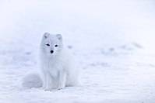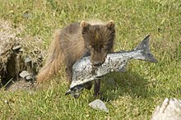

Works Cited must be included
Macpherson, A. H. (1969). The dynamics of Canadian arctic fox populations.
https://upload.wikimedia.org/wikipedia/commons/thumb/5/51/Fox_with_fish.jpg/220px-Fox_with_fish.jpg
https://upload.wikimedia.org/wikipedia/commons/thumb/1/1c/Iceland-1979445.jpg/200px-Iceland-1979445.jpg

